Loop of wire ~140mA RMS , frequency 10kHz
Battery pack- 7.2V- do not connect directly to motor
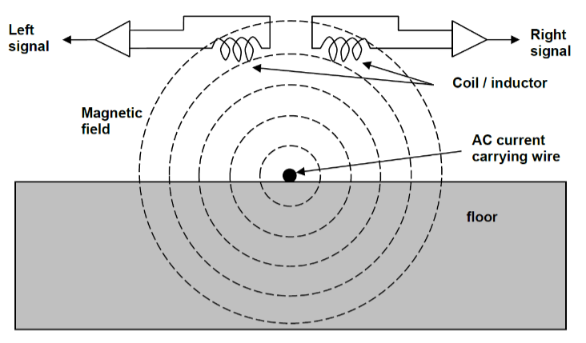
ferrite core Inductor- 330µH

-AC current in wire induces V in coil
- two coils side by side induce voltages of different amplitude based on Faradays law $ε=-N\frac{ΔΦ}{Δt}$.
- Induced emf = number of loops * change in flux over time
- Meaning more emf induced when more coils or more change I think
-interference from motors
-construct analogue circuits to amplify, filter and detect amplitude of signals
- Recommended circuit
- Use to simulate analyse and improve as necessary
- Calc values for parallel resonant circuit, low pass cut off, high pass cut off and amplifier gain
- Gain ensure balance bet high sensitivity, low controllability, and low sensitivity, low impact in motor speed
-how to turn sine wave into varying Dc- PWM stuff I guess
- Precision rectifier recommended-
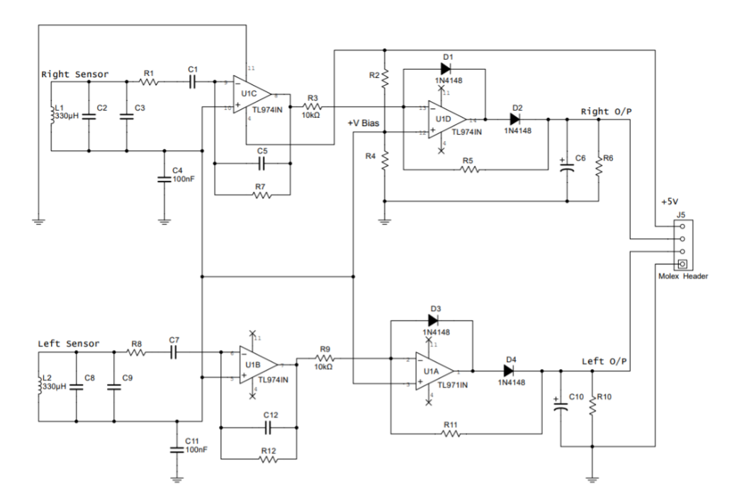
-designed to operate from single dc supply, resistor divider used to set dc operating point
- Suitable operating point voltage and why- Q point
- Common value used as dc operating pt for all further op amps added
To do:
-study components
- Which contribute to what kind of behave
-build circuit with components as suggested(replace LC system w small AC source)
- LT spice
- Project board
transient behaviour to reason for component functionality.
b) Steady-state behaviour for investigating the overall circuit behaviour.
c) AC sweep of the input source to reason for performance of your filters as well
as conditioning filters at the end. Also create a model for relating your DC
outputs based on the AC inputs. This model will be crucial for your
integration.
d) DC sweep to investigate minimum DC operating points (especially when the
battery power is low).
e) Fault diagnostics capability with simulated open and short circuit faults at
different points in the circuit.
f) Can you measure the power consumption of the overall circuit?
-study
- Transient behaviour- to reason for component functionality
- Steady state behaviour- for investigating over circuit behaviour
- AC sweep of input source- to reason for performance of filters and conditioning filters at end- also create model for relating DC outputs based on AC inputs- crucial for integration
- DC sweep to investigate minimum DC operating points- esp when battery power low
- Fault diagnostics w simulated open and short circuit faulst at different points
- Power consumption of overall circuit
-Can it be improved
-deisgn and construct subsystems and think ab integration
-demonstrate how can control motor speed based on position o fsensor
-approach designs
- Break into multiple subcircuits and design each until happy w individual operations
- Move towards integ w understanding of overall requirement (should output b limited or should pwm be limited)- investigate as many whar ifs as I can (what is cut off f change from xx to yy, what if back efm diode not connected, impact of changing gain of amplifier)

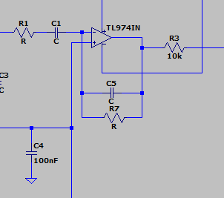
COMPONENTS- opamp 1 + 2

Op amp with resistor and capacitor in series going in and also in the feedback system resistor and capacitor in parallel
- active bandpass filter- w opamp so gain can affect stuff
- the ratios affect the allowed frequencies and stuff
Cut off frequency is -3dB point
-https://www.electronics-tutorials.ws/filter/filter_7.html
-separates a signal at one frequency or a range
- two cut offs- lower frequency and higher frequency
-cut-off of lower must be higher than cut-off of high pass w difference between -3dB point determining bandwidth

Lower cut off – 3dB is fc1, upper is fc2
$$f_{C1}=\frac{1}{2πC_{5}R_{7}}$$
$$f_{C2}=\frac{1}{2πC_{1}R_{1}}$$
probably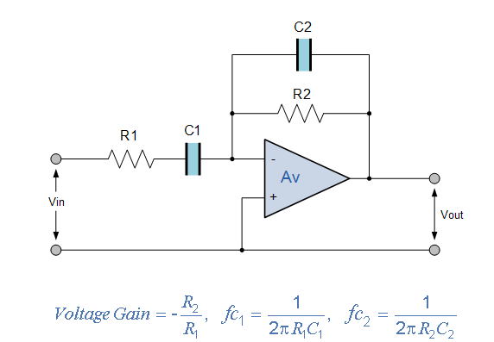

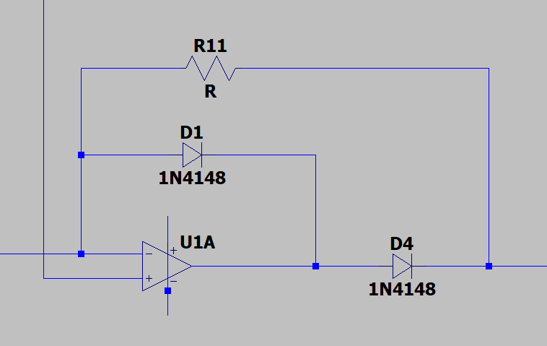
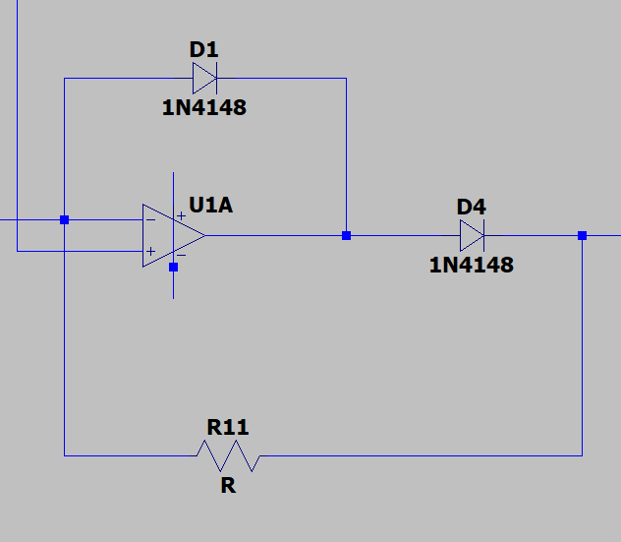
Other part- Half wave precision rectifier

-Diode across opamp with diode after and resistor across diode
https://www.ti.com/lit/an/sboa227b/sboa227b.pdf?ts=1770695111295#:~:text=Precision%20half%2Dwave%20rectifiers%20are,at%20frequencies%20up%20to%2050kHz.
Precision half-wave rectifiers are commonly used with other op amp circuits such as a peak-detector or bandwidth limited non-inverting amplifier to produce a DC output voltage.
-minimise noise by selecting low value resistors
-set output range based on linear swing
https://www.electronics-tutorials.ws/diode/diode_5.html
- AC to DC- passing either negative or positive half cycle of waveform + blocking the other

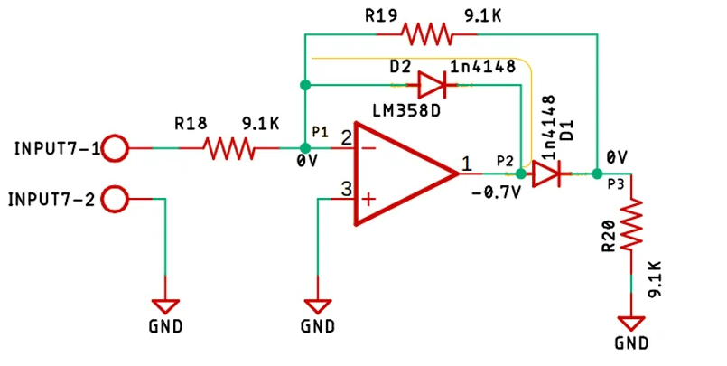
-https://circuitdigest.com/electronic-circuits/half-wave-and-full-wave-precision-rectifier-circuit-using-op-amp
-uses op amp to compensate for V drop across diode- not losing 0.7V voltage drop across
- additionally, can have gain at output
- zero output when ac neg
- add load resistor- practically formed voltage divider w 2 9.1k and one r20
- d2 conduct if positive half of sinusoidal is an input. Yellow line completed and op amp acting as inverting amplifier
-point 1 virtual ground, no I thru R19, output Point 2, V is -0.7V
-0V whenever +ve halfcycle to opamp
- negative half of AC- D2 is reverse biased, open circuit
- I thru R22, virtual grnd pt1
-diode conduct and get compensated output at p3
-output V will be -Vin/R2= Vout/R1, Vout= -R2/R1*Vin
- full wave recitifer better
Capacitor afterwards smooths
https://www.eleccircuit.com/full-wave-rectifier-with-an-op-amp-ic/
STUDY
A)transient behaviour to reason for component functionality.
b) Steady-state behaviour for investigating the overall circuit behaviour.
c) AC sweep of the input source to reason for performance of your filters as well
as conditioning filters at the end. Also create a model for relating your DC
outputs based on the AC inputs. This model will be crucial for your
integration.
d) DC sweep to investigate minimum DC operating points (especially when the
battery power is low).
e) Fault diagnostics capability with simulated open and short circuit faults at
different points in the circuit.
f) Can you measure the power consumption of the overall circuit?

